Practice Exercise – 2026-05-20
Registration No. : 2025/CS/079
Index No. : 25000799

( a )
2count – Invalid – variable name cannot start with a digit
item count – Invalid – variable name cannot include spaces
_itemCount – Valid

( b )
2count count
item count item_count
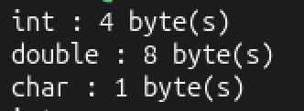
( c )
It prints the maximum number the data types int and double can hold.
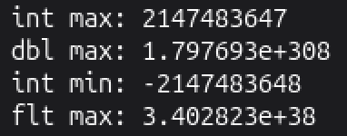
( d )
They get removed.
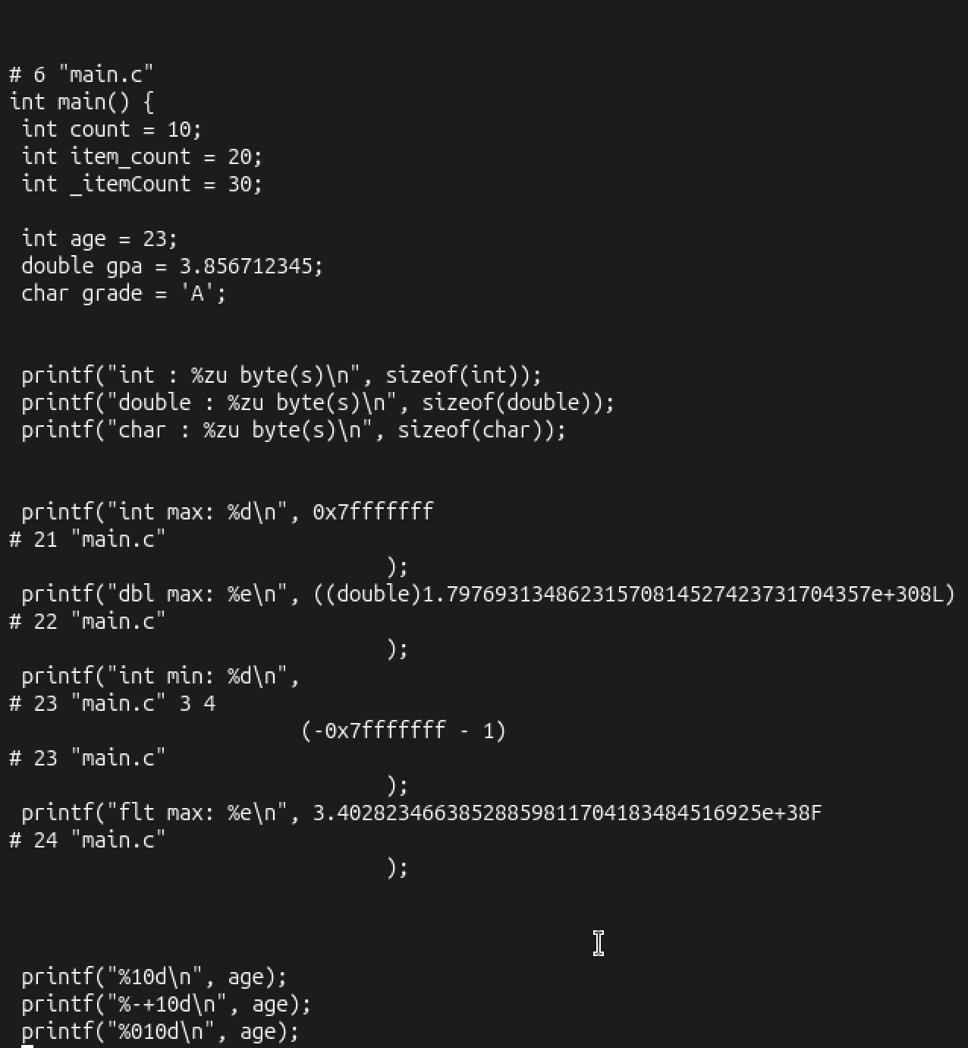
( e )
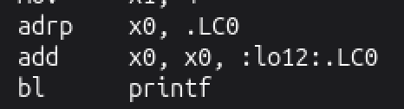

( f )
10d prints the value of age with a width of 10 characters. It is right aligned.
-+10d prints the value of age with a width of 10 characters and its sign. It is left aligned.
010d prints the value of age with a width of 10 characters. The whitespace at the start is filled with 0s.
.3f prints the value of gpa up to 3 decimal places
E prints the value of gpa in scientific notation
c = d first prints the character assigned to grade and then prints its ASCII value
